AGILE IMPLEMENTATION OF A PROCESS MATURITY MODEL IN HIGHER EDUCATION

IMPLEMENTACIÓN ÁGIL DE UN MODELO DE MADUREZ DE PROCESOS EN EDUCACIÓN SUPERIOR

Heidi Patricia Camacho Grass

CIDLIS Research Group. Industrial University of Santander. Bucaramanga, Colombia.

Ricardo Llamosa Villalba.

CIDLIS Research Group. Industrial University of Santander. Bucaramanga, Colombia.

Abstract
This research work presents a proposal to manage and improve educational process, for academic programs or courses in Higher Education. Particularly, we present a model for the internal processes improvement supported in the philosophy of current Maturity Models. The reference model designed and named "Educational Process Maturity Model - MEMORIA/PE" is an organizational architecture, structured into four categories of processes: Administrative Management, Strategic Administration, Operational Administration and Tactical Administration, in which are grouped and described "Management Practices" for compliance. MEMORIA/PE consists of five maturity levels that correspond to the state in which the processes can be found with respect to its management and its improvement. The process of implementation of MEMORIA/PE not only involves a process of formal assessment on the adherence to the practices of the model at a certain level of maturity, but it is necessary to continue with a process of reinterpretation of the model and constant improvement, which involves a cyclical process of development (iterations) of internal improvement projects. This coincides with the ontology of the agile methodologies where there is no "End Products", but evolving products, review or continuous improvement. That agile methodologies are applied in projects in complex environments, where you need to get results quickly, and requirements are changing and where innovation, competitiveness, flexibility and productivity are critical, designed an Agile Methodology Implementation of MEMORIA/PE, which integrates a set of best practices to work in Highly Productive Teams in order to obtain the best possible result, with partial and periodic deliveries from the priorities of stakeholders.

Keywords: Agile Methodology, Continuous Improvement, Process Management, Educational Processes.

Resumen
Este trabajo de investigación presenta una propuesta para gestionar y mejorar el proceso educativo, en programas académicos y/o cursos de Educación Superior. En particular, se presenta un Modelo para la mejora interna de procesos soportado en la filosofía de Modelos de Madurez actuales. El modelo de referencia diseñado y denominado “Modelo de Madurez de Procesos Educativos MEMORIA/PE”, es una arquitectura organizacional, estructurada en cuatro categorías de procesos: Gestión Administrativa, Administración Estratégica, Operativo y Táctica, en las que se agrupan y describen “Prácticas de Gestión” para su cumplimiento. MEMORIA/PE comprende cinco niveles de madurez que corresponden al estado en el cual se pueden encontrar los procesos, respecto a su gestión y mejora. El proceso de implementación de MEMORIA/PE implica no solo un proceso de valoración formal sobre la adherencia a las prácticas del modelo en determinado nivel de madurez, sino que se hace necesario continuar con un proceso de reinterpretación del modelo y mejora constante, lo que implica un proceso cíclico de desarrollo (iteraciones) de proyectos de mejora interna. Esto coincide con la ontología de las metodologías ágiles donde ya no hay “productos finales”, sino productos en constante evolución, revisión o mejora continua. Las metodologías ágiles son aplicadas en proyectos bajo entornos complejos, donde se necesita obtener resultados rápidamente, los requisitos son cambiantes y la innovación, la competitividad, la flexibilidad y la productividad son fundamentales, se diseñó una Metodología Ágil de Implementación de MEMORIA/PE, en la cual se integran un conjunto de buenas prácticas para trabajar en equipos altamente productivos con el fin de obtener el mejor resultado posible, con entregas parciales y periódicas a partir de las prioridades de los interesados.

Palabras Clave: Metodología ágil, mejora continua, gestión de procesos, procesos educativos.

Introduction
Education can be seen as a "service" that is offered by educational institutions, as well as companies involved processes, information, human resources (teachers, administrators, managers, etc.), technology, financial resources, a market to satisfy, competition, a customer-user (student who acquires the service) and a final customer (society in general), but this "service" manages a higher complexity because it is an intangible, hard to quantify, which implies the adoption of appropriate tools for proper management and monitoring, so that it meets the needs of stakeholders in the educational process (Camacho, 2013). Improve teaching process and therefore involves evaluating teaching and quality improvement, which leads to conclusion that Continuous Implementation Process Improvement is a philosophy that should take the Higher Education Institutions (Roman and Lopez, 2010). In this aspect, Largosenet, all (2004) mentioned by Mishra (2007) states that quality control has sometimes been dilated by the exercise of academic freedom thus hindering the implementation of quality characteristics in higher education; however the issue has been so important that has been increased in study and application in the educational context.

The quality assurance issue has been addressed in most countries, and although the process follows the same pattern, its implementation depends on the needs and requirements of national Higher Education systems (Lemaitre, 2008).According to a study by UNESCO (Martinez, 2006) is perceived academic credit expansion in countries that have been affected by factors such as the pursuit of efficiency, productivity and competitiveness for Total quality management, the internationalization of higher education (especially at the graduate level), and globalization and regional integration. Among the best accreditation models are: Accreditation Board for Engineering and Technology - ABET(USA), European Association for Quality Assurance in Higher Education -ENQA, Sistema de Acreditación Regional de Carreras Universitarias para el MERCOSUR -ARCU-SUR MERCOSUR. In Colombia, the System of Quality Assurance in higher education rests on two instruments: the qualified registration and accreditation of quality, in force since 1993. The National Accreditation Council (CNA) identified a set of academic and institutional conditions (factors and characteristics), which are supposed to define and frame quality education, and the achievement voluntary on the part of institutions and programs granted accreditation of quality (CNA, 2010) and (Larrondo, 2009).

In this context, we designed an educational process maturity model MEMORIA/PE for higher education that integrates best practices for the management, improvement and evaluation of the educational process in higher education, which contributes to improving the quality of processes, products and educational services to achieve better results in the learning process of students. The model allows perform an incremental improvement of the educational process integrating strategic, tactical and operational administration, autonomy without switching teachers, which does not require any obligation on the teaching methodology or learning methodology to use, but provides guidelines for their definition, management, monitoring and continuous improvement. In order to facilitate the process of practices adoption defined by MEMORIA/PE, it was defined an agile methodology implementation supported on five phases of agile project methodology defined by the PMI - Agile Certified Practitioner (PMI-ACP ®): Visualization, Speculation, Exploration, Adaptation and Close (Hignsmith, 2009).

This paper describes the methodology used in the development of the work, the structure of the maturity model MEMORIA/PE, the methodology of model implementation and results of the pilot test.

Methodology
The methodology used in this research is Qualitative type, Not Experimental and Transversal. Is Qualitative, because from a literature review exploratory study of patterns and management practices of processes for the preparation and validation of the Maturity Model shows the behavior of a specific scenario. It is a type Not Experimental study, for the reason that in process of implementing Maturity Model, independent variables are not manipulated to study the situation, but analyzes the phenomenon as it occurs in its natural context. According to its temporary location this research is Transversal because, Maturity Model implementation in a course is done in a defined time period (two semesters). The development of the research project involved the following stages:

Stage 1. Design and development of the Maturity Model and its components:
- Identification of needs and definition of the research problem
- Definition of the lifecycle of the educational process
- Exploratory Literature Review of best management practices. For this, the information was searched in databases such as ISI - Web of Knowledge, SCOPUS, SpringerLink, ProQuest, Elsevier, EBSCO, Emerald, Redalyc and other queries to entities such as the Ministry of National Education in Colombia.
- Preliminary Design: Educational Process Maturity Model for Higher Education –MEMORIA/PE and Agile Implementation Methodology MEMORIA/PE. The Maturity Model is a descriptive construct developed systemic and analytically through integrating concepts and relationships, mainly from the approach and strengths developed by three (3) reference Maturity Models: CMMI-DEV (SEI, 2010), CMMI-SVC (SEI, 2010) and Business Process Maturity Model (BPMM) from (OMG, 2008).

Stage 2.Agile Implementation of the Maturity Model:
- Initial Diagnosis of implementation scenario
- Training in the maturity model.
- Definition of the Action Plan
- Agile Implementation Maturity Model - Pilot.
- Process Assessment
- Feedback and adjustments to models designed.

Educational Process Maturity Model for Higher Education -MEMORIA/PE-

Structure MEMORIA/PE
MEMORIA/PE is a framework of best management practices applied to the educational process a Higher Education Institution. The model does not specify the workflow that must follow an institution or program to provide its course offerings, and does not define the goals or objectives to achieve during its execution, but it describes the processes that are part of the education service, the relations between them and management practices that can be used to obtain better results during the teaching-learning process, without altering the teaching autonomy.

The key element in MEMORIA/PE is the "Management Practices" used to plan, monitor and control the performance of educational activities. Each Management Practice is instantiated and grouped, according to their affinity in "Process Areas", and these in turn, congregate in four "Processes Categories" and seven "sub-categories". The Model consists of 24 process areas as it is evidenced in the Table 1. The Process Categories include: Administrative Management, associated with sub-categories Direction and Management; Operational Administrative, reference Authoring, Instruction and Evaluation services of teaching and learning; Tactical Administrative involves human resource management, knowledge management, communications, measurement and quality of all processes. Finally, Strategic Administrative manages the Research, Development and Innovation (R+D+i) and improving the education system.

Processes Categories | Sub-categories | Process Areas / Maturity Level = ML
Administrative Management | Direction | - Decision Analysis and Making (ML 3)  - Causes Analysis (ML 5)  - Strategic Management of Educational Process (ML 3)
Administrative Management | Management | - Requirements Management (ML 2)  - Educational Process Planning (ML 2)  - Educational Process Monitoring and Control (ML 2)  - Risk Management (ML 3)  - Educational Process Quantitative Management (ML 4)
Operational Administrative | Authoring | - Requirements Definition (ML 3)  - Design and Development of Education Product (ML 2)  - Verification of Educational Products (ML 3)  - Validation of Educational Products (ML 3)
Operational Administrative | Instruction | - Instruction Service Delivery (ML 2)  - Instruction Service Continuity (ML 3)  - Incident Resolution and Prevention (ML 3)
Operational Administrative | Evaluation | - Evaluation (ML 3)
Tactical Administrative | Quality Assurance | - Configuration of Knowledge Assets Management (ML 2)  - Measurement and Analysis (ML 2)  - Quality Assurance (ML 2)  - Training (ML 3)  - Communications Management (ML 3)  - Performance Measurement Educational Process (ML 4)
Strategic Administrative | Systemic Improvement | - Definition and Improvement Process (ML 3)  - Research, Development and Innovation (ML 5)
Table 1. Process Areas, Processes Categories and Sub-categories.
Source: Camacho, Llamosa and Valdivieso, (2013)

Facilitating implementation, process areas described by binding components and components that explain the required components and indicate the sub-products and practices suggested, as shown in Figure 1. Furthermore, the maturity model defined maturity levels used to describe the route to be followed by an institution that wishes to improve processes incrementally ​​to provide educational services (authorship, instruction and assessment), by offering courses or programs academic quality, and ensuring compliance with the objectives and stakeholder satisfaction. MEMORIA/PE describes five maturity levels are numbered 1 through 5, as shown in Figure 1.
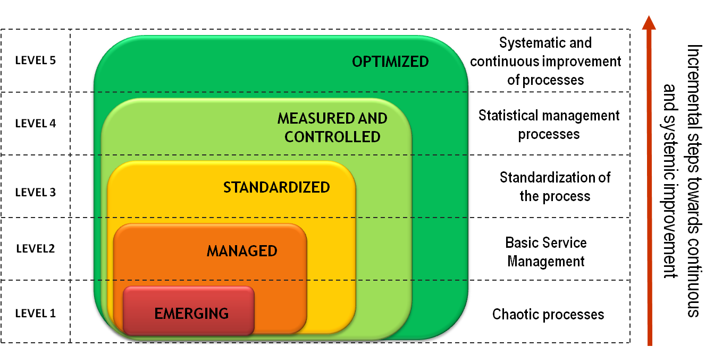
Figure 1.Maturity Levels.
Source: Camacho, (2013)

Each maturity level corresponds to a state in which processes can be found with regard to its management and improvement. It starts at Level 1: Emerging, where processes are chaotic and disorganized, up to a Level 5: Optimized, where processes are continuously improved supported by quantitative measurements to estimate and predict their behavior. Each maturity level has an associated set of process areas that support the purpose of each level in the process improvement cycle that can make an institution offering courses or programs. The implementation of the process areas of each level the institution prepares for its evolution to the next level of maturity. Level 2: Managed, related practices for the management of the activities of the course or program and defines basic services to offer a course or program, at Level 3: Standardized, organizes the processes that comprise the entire life cycle of a course and establish practices for managing the processes defined.

Agile Implementation Methodology MEMORIA/PE
The application of agile methodologies is an innovative approach to improving project management, which combines features such as teamwork, commitment of all parties and project constraints, focused always add value to the institutions and stakeholders, in this specific case for those interested in the teaching-learning process. The Agile Implementation Methodology designed integrates a set of best practices for working in Highly Productive Teams in order to obtain the best possible results, with partial and periodic deliveries from the priorities of stakeholders.

An implementation process requires initial conditions that ensure its success of the project, to generate an appropriate environment of trust, commitment and orientation towards achieving a common goal. For this to be achieved the following guidelines are recommended as a strategy for implementation of MEMORIA/PE (see Figure 2).

The roles involved in the process of implementing MEMORIA/PE vary according to the scope and objectives proposed. However, among the proposed basic roles in implementing agile methodology, include four (4) key roles (see Figure 3): Product Owner, Development Team, Master and Stakeholders.

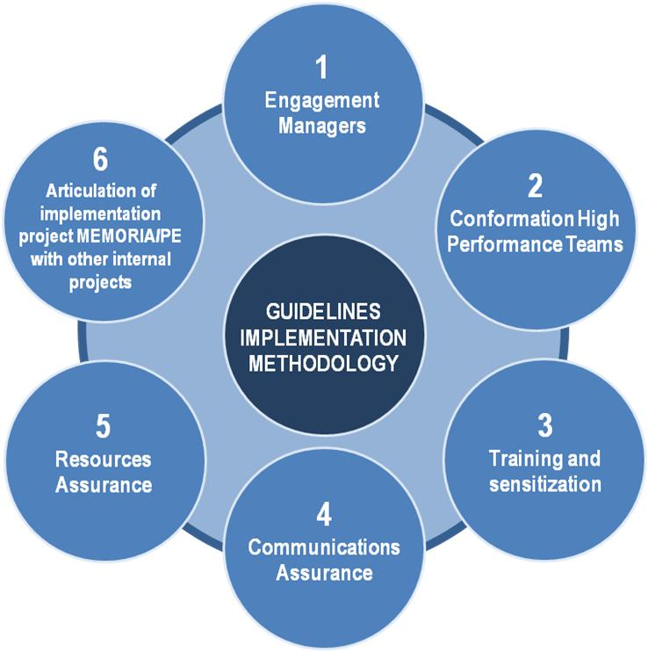 |  | 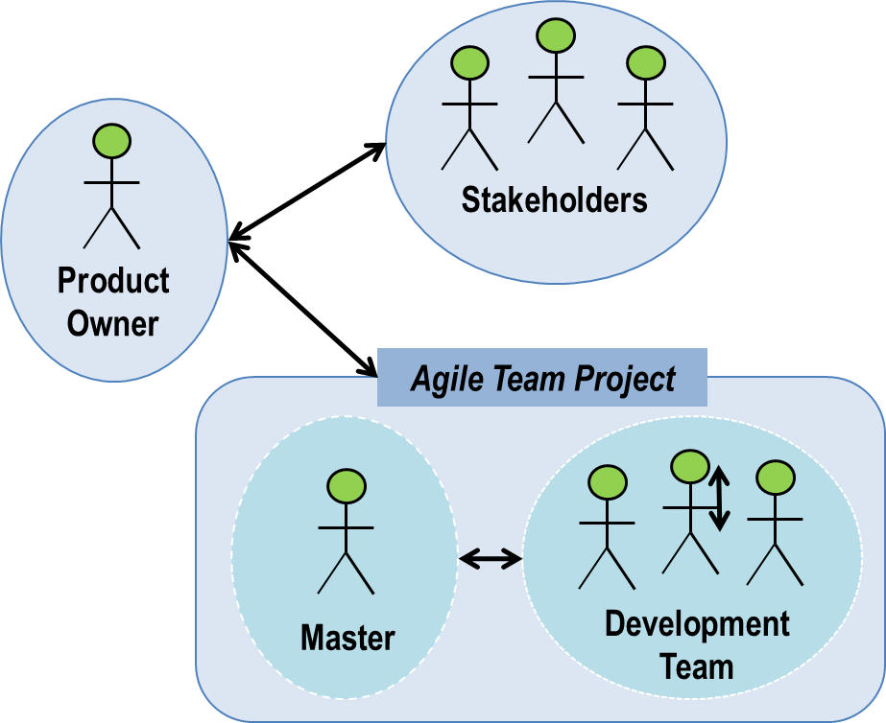
Figure 2. Guidelines implementation agile Methodology  Source: Camacho, Llamosa and Valdivieso, (2013) |  | Figure 3. Roles involved in the process of implementing MEMORIA/PE.  Source: Camacho, Llamosa and Valdivieso, (2013)
The agile implementation process of maturity model part of the Vision of the general concept of improving the development of the educational process (Envision Stage), on it, the team is developing small increases in the order of priority they need those interested in the teaching-learning process. The short development cycles of the implementation project, are called iterations and perform until it decides not to evolve more the product/deliverable generated. This development scheme consists of five (5) stages (see Figure 4):
- Stage: Envision or concept
- Stage: Speculation
- Stage: Exploration
- Stage: Adaptation (Review)
- Stage: Close
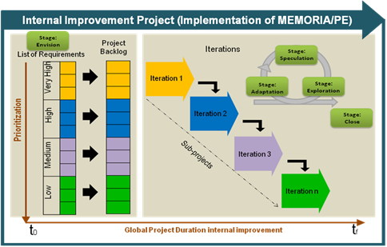
Figure 4. Stages of implementation methodology
Source: Camacho, Llamosa and Valdivieso, (2013)

In the Envision Stage creates the concept or idea of ​​the Internal Improvement Project to develop, that is, establishing the vision of the products, services or improvements that are desired by implementing MEMORIA/PE, from the identification of needs, requirements or issues identified by the stakeholders in the educational process at the institution. It therefore, defines the scope and goals of the implementation process and decides and selects team.

At the Speculation Stage, the vision of improvement project becomes a set of requirements or features to be developed to meet the needs of stakeholders improved. It generates a plan deliveries or releases from the information generated in Envision Stage.

The Exploration Stage is iterative and incremental development of actions to improve teaching-learning process, according to defined management practices MEMORIA/PE, to be implemented. This stage comprises the steps:
- Planning the Iteration.
- Architectural Modeling of the teaching-learning process: In this Phase is performed architectural modeling of processes, information and technology teaching and learning process (see Figure 5).
- Functional Operation: The implementation of the improvements arising from the practices of the maturity model (see Figure 6).
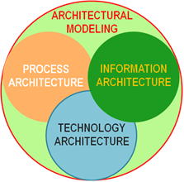 |  | 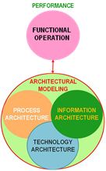
Figure 5: Architectural Modeling  Source: Camacho, Llamosa and Valdivieso, (2013) |  | Figure 6: Operation Functional  Source: Camacho, Llamosa and Valdivieso, (2013)

In Adaptation Stage reviews the findings released during the iterations, the current status and performance of the process and the team, adapt if necessary. This stage includes monitoring, review and evaluation of both the deliverables and the process (see Figure 7):

- Quantitative Measurement (Quantification): It identifies the characteristics or variables to be measured for products and processes, measurement scales, the domain of values ​​of the variables, the instruments or data collection tools and perform the respective data analysis.
- Reasoned Measurement (Qualification): This measure seeks to assign value judgments on quantitative measurements obtained in order to establish the conceptual status of processes and products.
- Comparative Measurement: This activity is intended to compare the results with the internal measurements of the environment (Benchmarking) through formal assessments that allow obtaining accreditation or certification, in order to identify internal dates against the market.
- Aware Assessment: Making evidence-based assessment using assessment rubrics and scales defining each rating criteria to rank the level of process maturity and identifying opportunities for improvement, suggestions and strengths.
- Aware Development: From the results of the rating Aware, take decisions against the plans, programs and projects to improve the institution to develop and thus continue the cycle of continuous improvement and process maturity.

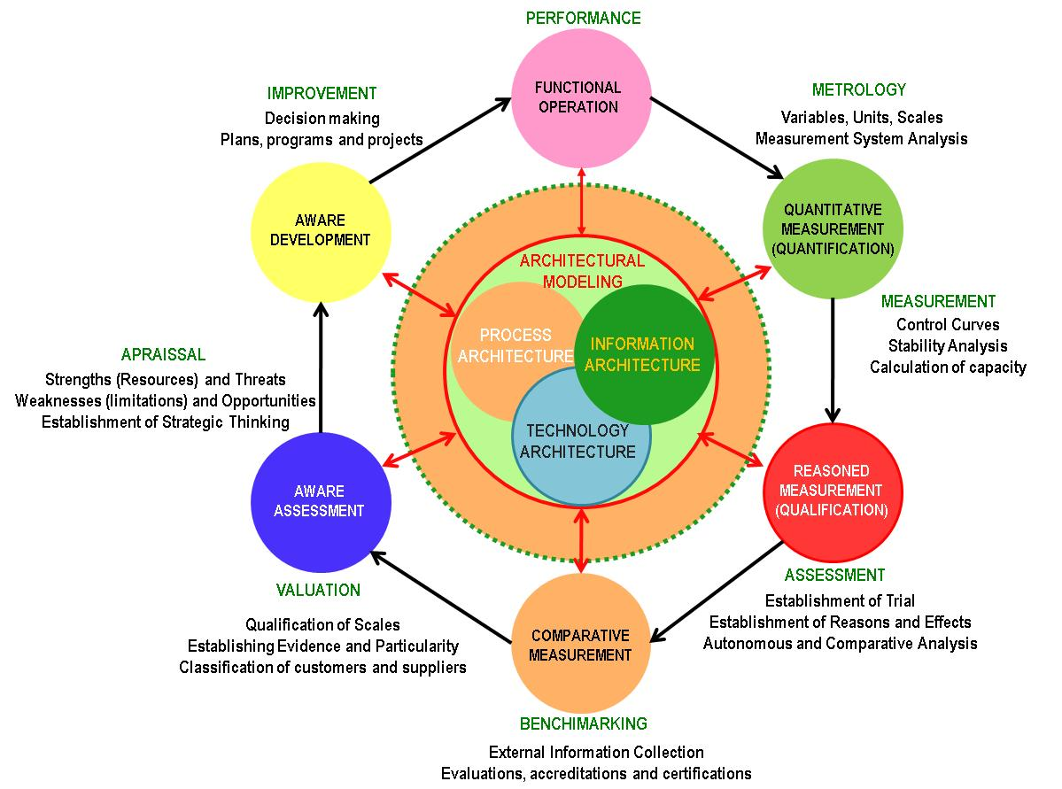
Figure 7: Method of Assessment Maturity Model
Source: Camacho, Llamosa and Valdivieso, (2013)

In Closing Stage concludes the project and the teams have an opportunity to reflect on their work and make decisions based on what they learned (Highsmith, 2004).

Pilot Results
In order to verify the functionality of the agile implementation methodology, developed a pilot in a course offered by the CIDLIS Research Group, specifically in the Course Statistics and Probability for Engineers during the first and second half of 2012. With the following results:

Envision Stage: Diagnostic evaluation was performed to compare the level of practical implementation of the model in the course Statistics and Probability for Engineers (CEPI), in order to establish the basis for defining the scope of the implementation process maturity model. It was defined as goal maturity levels 2 and 3.

Speculation Stage: At this stage the timetable for the implementation of the maturity model was defined as follows: An academic semester with three modules representing a release with three iterations

Exploration Stage: At this stage the actions planned in phase of speculation were developed and improvements were incorporated simultaneously to both the maturity model as to the actions of the course. Architectural model was defined the teaching-learning process of the course.(See Figure 8).

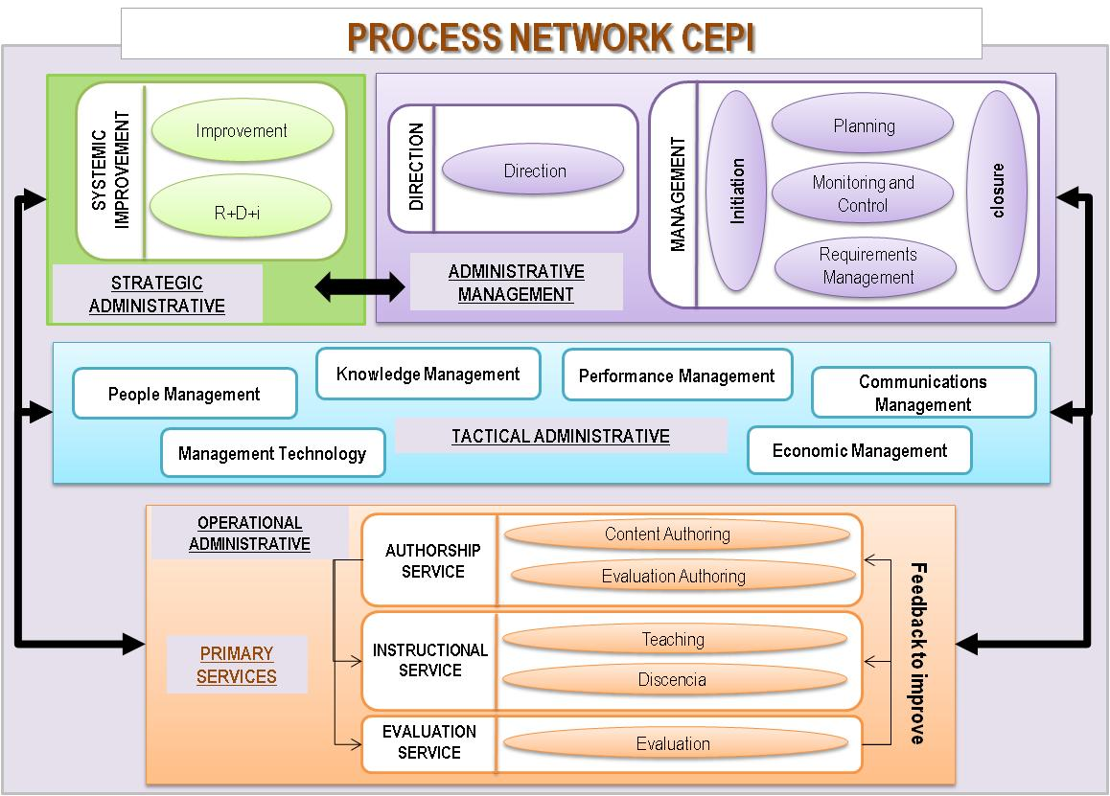
Figure 8: Architectural Modeling of the teaching-learning process.
Camacho, Llamosa and Valdivieso, (2013)

Adaptation Stage: This stage allowed us to measure the performance of the processes defined in the course and therefore track the implementation of the maturity model. In each iteration were identified and analyzed the weaknesses and strengths, and corresponding improvements and to make adjustments parallel the maturity model and implementation methodology. As results of the three iterations were obtained results as shown below:

- Process Areas of the category "Operational Administrative":Two (2) areas of process (Design, Development or Product and Instruction Education Service Delivery) were implemented at 100%, the Evaluation process area reached 75% adherence, these three correspond to a maturity level two (2). The other areas of process levels that correspond to level three (3) of maturity, is below 67% of implementation (see Figure 9).
- Process Areas Category "Administrative Management": Three (3) areas of process (Analysis and Decision Making, Strategic Management of Education Process and requirements Management) implementation reached a level of 100%. (See Figure 10).
- Process Areas Category process "Management Tactics": No areas of process were implemented to 100%. (See Figure 11).
- Process Areas Category "Strategic Management": The process area Process Definition and Improvement reach 75% implementation.

In summary we have three (3) of the nine (9) areas of Level 2 process 100% fulfilled the specific objectives of your area, so rigorously applying the principles of the evaluation method, we can say that the CEPI course not enough even to value a maturity level 2.

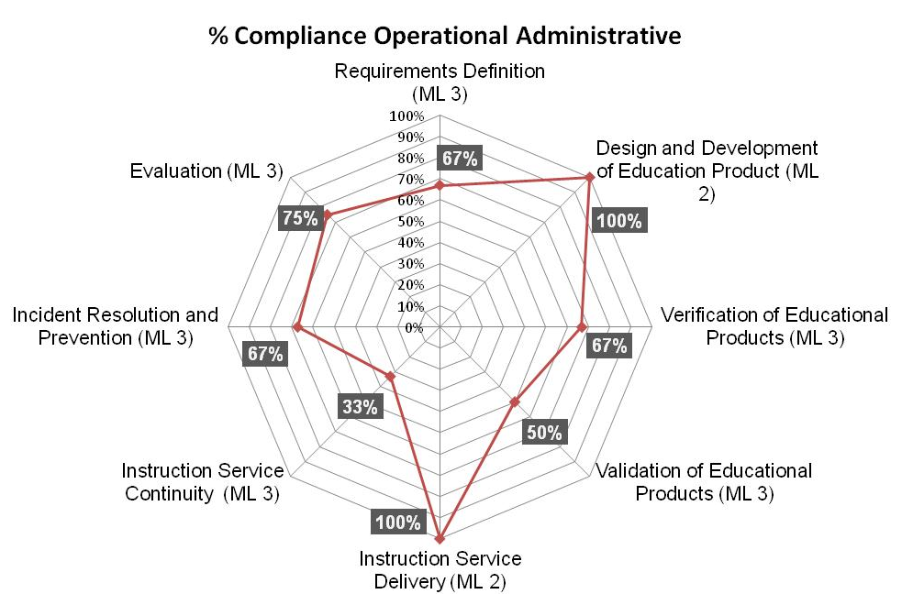 |  | 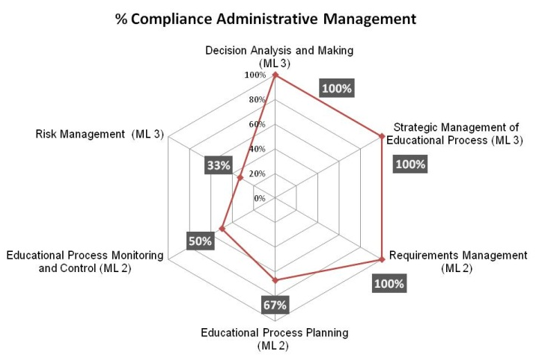
Figure 9. Process Areas of the category "Operational Administrative":  Source: Camacho, Llamosa and Valdivieso, (2013) |  | Figure 10. Process Areas Category "Administrative Management  Source: Camacho, Llamosa and Valdivieso, (2013)

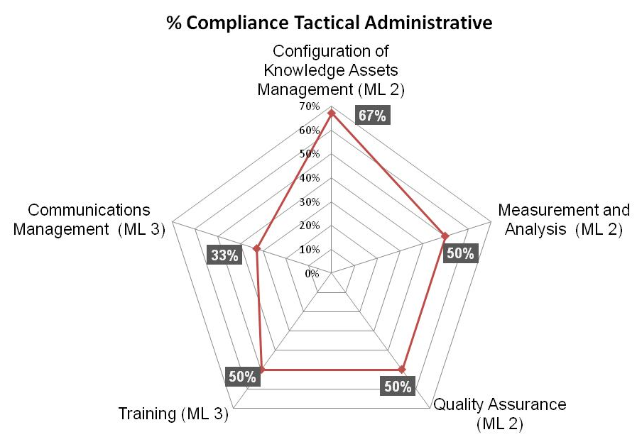
Figure 11. Process Areas Category process "Management Tactics":
Source: Camacho, Llamosa and Valdivieso, (2013)

Closing Stage: In the closing stage of the implementation process is socialized the results found and identified and documented lessons learned. For this we conducted an outreach session with students of the three groups, the teachers in charge of the groups, the teaching staff and researchers.

Conclusions

- The constant self implementing model practices daily, gathering information and evidence as part of daily activities and tracking indicators allow ongoing assessment process to establish the status of processes and reduce gaps.
- The incorporation of a management process and continuous process improvement maturity levels during CEPI, involved the definition and formalization of the threads involved in the educational process and outcomes of each activity.
- The definition of threads directly relevant to the categories and subcategories of processes defined in the maturity model, this structure allowed for a continuous assessment of compliance with the same model practices while developing course activities.
- A pilot test is not enough to confirm that the improvement of the threads that make up the educational process and the adoption of continuous improvement in the learning process is directly related to improving student academic performance, Repeating the process until reaching a definitive conclusion.
- The initial effort to implement the maturity model is high, but is expected to stabilize and automate processes, this effort is reduced significantly.

Recommendations
- Based on the principle that everything can be improved, taking into account the results found in the research process is recommended in future research include the topic of technology management in the areas of process maturity model, considering the great success of this subject in the educational context.
- In order to facilitate the achievement of a specific maturity level and the implementation of the model, it is recommended to incorporate the implementation methodology prioritization process categories, in order to prioritize areas of interest.

Future Work
• Extend the reach maturity model to other higher education institutions missionary functions, such as the research and extension services so that the model can be applied to an institution in all its components.
• Incorporation of agile methods in the classroom as a tool for appropriate managing and monitoring.

Acknowledgment
This research was supported by the Vice-Rector for Research and Extension (VIE) and CIDLIS Research Group at the Universidad Industrial de Santander (Colombia).

References

- Camacho Grass,Heidi. (2013). Master Thesis: Propuesta de Integración de Mejores Prácticas para la Gestión, Mejora y Valoración del Proceso Educativo en la Educación Superior, Universidad Industrial de Santander.
- Camacho, Heidi. Llamosa, Ricardo. Valdivieso, Raul. (2013). Modelo de Madurez de Procesos Educativos. Directrices para la gestión, mejora y valoración del Proceso Educativo, orientados a la mejorar la calidad en la Educación Superior. Universidad Industrial de Santander. Bucaramanga.
- Consejo Nacional de Acreditación. CNA. [Retrieved December 2011]. Available in:http://www.cna.gov.co/1741/article-187264.html.
- Consejo Nacional de Acreditación. CNA. (2013). Lineamientos para la acreditación de programas de pregrado. Bogotá. [Retrieved May 2013]. Available in:http://daca.univalle.edu.co/Lineamientos-PREGRADO-CNA-2013.pdf
- Highsmith, Jim. (2009).Agile Project Management: Creating Innovative Products (2nd Edition). Pearson Education. ISBN 0321659171, 9780321659170. 432 pages.
- Larrondo Petrie, María M. (2004). Towards An Engineering Education Capability Maturity Model. College of Engineering, Florida Atlantic University. American Society for Engineering Education Annual Conference & Exposition.
- Lemaitre, María José. (2008). Una mirada actual al desarrollo de procesos de aseguramiento de la calidad. Universidad Católica de Chile. [Retrieved Jul 2011]. Available in: http://cms-static.colombiaaprende.edu.co/cache/binaries/articles-186502_MJ_Lemaitre.pdf?binary_rand=9461.
- Martínez, Eduardo. (2006).La evaluación de la educación superior. UNESCO. Montevideo Uruguay.
- Mishra, Sanjaya. (2007).Quality Assurance in Higher Education: An Introduction. National Assessment and Accreditation Council (NAAC) & Commonwealth of Learning COL). Bangalore. India. 2007. P 113. ISBN 978-81-89842-07-9.
- Object Management Group. (2008).Business Process Maturity Model (BPMM).Version 1.0. 496 p.
- Roman, Ana Isabel, López, Mª Cinta. (2010). Implantación de un proceso de mejora continua (PDCA) en la enseñanza universitaria. [Retrieved May 2011]. Available in: http://calidad.umh.es/files/2010/10/Hispanoluso_env%C3%ADo.pdf
- Software Engineering Institute (SEI). 2010).CMMI® for Development, Version 1.3. Improving processes for developing better products and services. Carnegie Mellon University. 482 p.
- Software Engineering Institute (SEI). (2010). CMMI® for Services, Version 1.3. Improving processes for providing better services. Carnegie Mellon University. 508 p.

About authors

HEIDI PATRICIA CAMACHO GRASS
Industrial Engineering and Masters in Industrial Engineering from the Industrial University of Santander. Currently a Researcher of the CIDLIS Research Group from the Industrial University of Santander. Bucaramanga – Colombia. E-mail: heidipcg@gmail.com

RICARDO LLAMOSA VILLALBA
Systems Engineer from the Industrial University of Santander, PhD in Telecommunications, Currently a Scientific Director of the CIDLIS Research Group from the Industrial University of Santander. Bucaramanga – Colombia. E-mail: nrllamos@gmail.com

